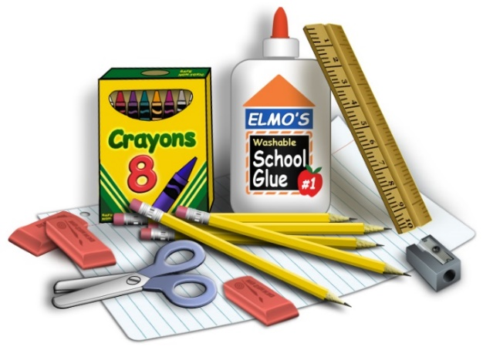
MCA School Supply List – All Students

Please mark each supply with your name as you pack your backpack for the first day of school.

NIV Discoverer’s Bible for Early Readers: Large Print (Can be found on Amazon)
1 backpack – no wheels, large enough to hold a 9” by 12” folder
1 umbrella
1 oversized paint shirt (long-sleeved button down shirt)
3 pkgs. of 24 crayons (Crayola)
2 packs of #2 pencils
Small Pack Colored Pencils
Small Pack Washable Markers
1 standard size pencil box
4 large glue sticks
3 pink erasers
Scissors (blunt children’s for kindergarten)
Standard Wooden Ruler
3 rolls of paper towels, 3 boxes of tissues, 2 containers of Clorox Wipes, 1 bottle of hand sanitizer,
and hand wipes (These items do not need to be marked with your name.)

Additional supplies needed for the first day of school by Grade level:

Kindergarten:
2 tubes of Play-doh,
3 plastic folders (not paper)
Change of clothes to be kept in backpack in case of emergency
1st Grade:
4 folders
1 Marble Notebook
1-Composition notebook wide-ruled,
Extra t shirt/shorts in backpack in case of emergency
2nd Grade:
6- Bottom pocket folders
1-One subject wide-ruled spiral notebook
1-Composition notebook wide-ruled
3rd Grade:
Small Dry Erase Board, Dry Erase Markers, & Dry Erase Eraser
1 inch Solid Color Binder/Notebook
6 Bottom Pocket Folders with 3 punched holes to go in Binder.
Wide-ruled Notebook Paper
One subject wide-ruled spiral notebook
4th Grade:
Small Dry Erase Board, Dry Erase Markers, & Dry Erase Eraser
1 ½ inch Binder/Notebook & 3 Bottom Pocket Folders to go in Binder
6 Bottom Pocket Folders
Wide-ruled Notebook Paper
One subject wide-ruled spiral notebook
5th Grade:
1 inch Solid Color Clear View Binder/Notebook,
8 Bottom Pocket Folders with 3 punched holes to go in Binder
5 Sturdy Bottom Pocket Folders for Special Classes
Wide-ruled Notebook Paper
One subject wide-ruled spiral notebook

