MCA School Supply List – All Students

Please label supplies with your name as you pack your backpack on the first day of school.

NIV Discoverer’s Bible for Early Readers: Large Print (Can be found on Amazon)
1 Backpack – no wheels, large enough to hold a 9” by 12” folder
1 Umbrella
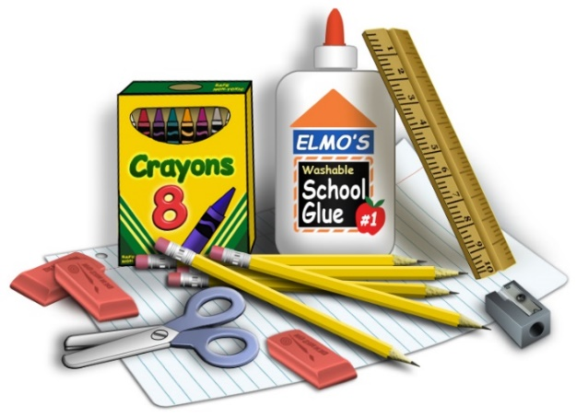
1 Oversized Paint Shirt (long-sleeved button-down shirt)
3 Pkgs. of 24 Crayons (Crayola)
2 Packs of #2 Pencils
Small Pack Colored Pencils
Small Pack Washable Markers
Pack of Dry Erase Markers
1 Standard Size Pencil Box
4 Large Glue Sticks
3 Pink Erasers
Scissors (blunt children’s for kindergarten)
Standard Wooden Ruler
3 rolls of Paper Towels, 3 Boxes of Tissues, 2 Containers of Clorox Wipes, 1 Bottle of Hand Sanitizer,
and Hand Wipes (These items do not need to be marked with your name.)

Additional supplies needed for the first day of school by Grade level:
Kindergarten:
2 Tubes of Play-doh,
3 Plastic Folders (not paper)
Change of Clothes to be kept in Backpack in Case of Emergency
1st Grade:
2 Folders
1 Marble Notebook
1-Composition Notebook Wide-Ruled,
Extra T Shirt/Shorts in Backpack in Case of Emergency
2nd Grade:
6- Bottom Pocket Folders
1-One Subject Wide-Ruled Spiral Notebook
1-Composition Notebook Wide-Ruled
3rd Grade:
Small Dry Erase Board, Dry Erase Markers, & Dry Erase Eraser
1 inch Solid Color Binder/Notebook
6 Bottom Pocket Folders with 3 punched holes to go in Binder
Wide-ruled Notebook Paper
One Subject Wide-Ruled Spiral Notebook
4th Grade:
Small Dry Erase Board, Dry Erase Markers, & Dry Erase Eraser
1 ½ inch Binder/Notebook & 3 Bottom Pocket Folders to go in Binder
6 Bottom Pocket Folders
Wide-ruled Notebook Paper
One Subject Wide-Ruled Spiral Notebook
5th Grade:
1 inch Solid Color Clear View Binder/Notebook,
8 Bottom Pocket Folders with 3 punched holes to go in Binder
5 Sturdy Bottom Pocket Folders for Special Classes
Wide-ruled Notebook Paper
One Subject Wide-Ruled Spiral Notebook 6/9/23

