M A R L T O N C H R I S T I A N A C A D E M Y

WAYS TO ORDER YOUR UNIFORM

1. ONLINE:  To view uniform options, pricing, and shop year-round, visit: | 2. IN STORE:  Visit us at our closest servicing retail location:
2240 W. Marlton www.flynnohara.com/school/NJ089
2240 W. Marlton Pike
Cherry Hill NJ 08002
856-931-8838
OR
PLEASE NOTE:
Be sure to order early, as orders placed after July 15 cannot be
guaranteed for delivery by the first day of school!
3. OVER THE PHONE:
Flynn O'Hara's Customer Service Department is available Monday through Saturday year-round to answer questions, track returns, and place orders:
Call us toll-free at: (800) 441-4122

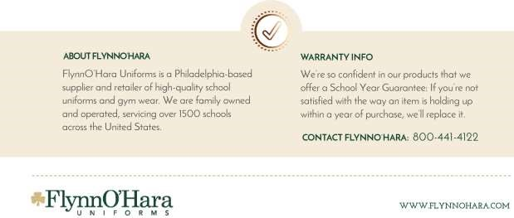
Following is the official school dress code of
Marlton Christian Academy Elementary:

BOYS: K – 5th
  - Navy Twill Pants
  - Navy Boy’s Twill Walking Shorts (Spring/Fall)
  - White Short Sleeve Buttondown Collar Shirt w/School Logo
  - White Long Sleeve Buttondown Collar Shirt w/School Logo
  - Navy Tie
  - White Short Sleeve Polo Shirt w/School Logo (Shirts are tucked in 3rd-5th grade)
  - White Long Sleeve Polo Shirt w/School Logo (Shirts are tucked in 3rd-5th grade)
  - Lipstick Red V-Neck Pullover Sweater w/School Logo
  - Lipstick Red V-Neck Cardigan Sweater w/School Logo
  - Black/Brown Reversable Leather Belt or Black Woven Military Web Belt (all students are required to wear)
  - Navy/Black Crew Socks
  - Black Oxford Shoe

GIRLS: K – 2nd
- Navy Plaid Drop Waist Jumper w/School Logo
- White Short Sleeve Peterpan Collar Blouse w/School logo
- White Long Sleeve Peterpan Collar Blouse w/School logo
- Lipstick Red Crew Neck Cardigan Sweater w/School Logo
- White Ladies SS 2-Button Pique Fitted Shirt w/School Logo
- White Long Sleeve Polo Shirt w/School Logo
- Navy Flat Front Girls Slacks
- Navy Girl’s Twill Walking Shorts (Spring/Fall)
- Navy Opaque Nylon or Orlon Knee-Hi, Socks or Navy Opaque or ribbed Tights
- Black Oxford Shoe

GIRLS: 3 - 5th
- Navy Plaid 2 Panel Skort
- White Short Sleeve Buttondown Collar Shirt w/School Logo
- White Short Sleeve Buttondown Collar Blouse w/School Logo
- White Long Sleeve Buttondown Collar Shirt w/School Logo
- White Long Sleeve Buttondown Collar Blouse w/School Logo
- Navy Criss-Cross Girl's Tie
- White Ladies SS 2-Button Pique Fitted Shirt w/School Logo
- White Long Sleeve Polo Shirt w/School Logo
- Lipstick Red V-Neck Cardigan Sweater w/School Logo
- Lipstick Red V-Neck Pullover Sweater w/School Logo
- Navy Flat Front Girls Slacks
- Navy Girl’s Twill Walking Shorts (Spring/Fall)
- Navy Opaque Nylon or Orlon Knee-Hi, Socks or Navy Opaque or ribbed Tights
- Black Oxford Shoe

- Uniforms must be worn during school hours, including Beforecare and Aftercare.
- Official Uniform to be worn to Chapel each week and to School Performances: navy twill pants, navy plaid drop waist jumper(k-2), Navy Plaid skort (3-5th) collar shirts, belt(all students), tie(all boys, girls 3-5th), black dress shoes, Navy/black socks, Navy tights (girls), Red Sweater
- ON GYM DAYS, Red Gym T-Shirt w/School Logo, Navy Micromesh Nylon Gym Shorts (Spring/Fall), Navy Heavy Weight Sweatshirt w/School Silkscreen, Navy Heavy Weight Sweatpant
- ON THE REMAINING THREE WEEKDAYS, students will wear any approved uniform items purchased.
* Parent Spirit Wear is available at www.flynnohara.com/school/NJ089

